

**Object-Oriented Programming in Java** **Report**

Naseer Al-Musalhi

# **Introduction**

Java stands as a widely adopted high-level programming language which provides strong support for Object-Oriented Programming (OOP). The paradigm of OOP focuses on objects which contain both data elements and behavioral functions. Java's class-based structure together with its strict OOP principles enables developers to create scalable applications that are both modular and maintainable.

This research examines Java's basic Object-Oriented Programming (OOP) principles together with its essential elements and class relationships and benefits and implementation methods. The research draws its information from Fundamentals of OOP and Data Structures in Java (Wiener & Pinson, 2000) as well as GeeksforGeeks and Medium articles about OOP concepts.

# **Core Principles of OOP in Java**

## **Encapsulation**

A class contains both data elements (fields) and methods which operate on that data through encapsulation. The bundling of data (fields) and methods that operate on that data into a single unit called a class. The bundling of data (fields) and methods that operate on that data into a single unit called a class. It allows for data hiding using access modifiers (private, public, protected), ensuring that internal object states are shielded from unauthorized access. Controlled access is facilitated through getter and setter methods.

## **2.2 Abstraction**

The internal details of methods are concealed through abstraction while exposing only the necessary functionalities. In Java, abstraction is achieved through abstract classes and interfaces, enabling the separation of what an object does from how it does it.

## **2.3 Inheritance**

A new class (subclass) can obtain properties and behaviors from an existing class (superclass) through inheritance. This promotes code reuse, reduces redundancy, and enables hierarchical class organization. Java uses the 'extends' keyword to implement inheritance.

## **2.4 Polymorphism**

The ability of objects to function as instances of their parent class instead of their actual class is known as polymorphism. It is categorized into:

- Compile-time polymorphism (method overloading)

- Runtime polymorphism (method overriding)

This feature promotes flexibility and extensibility in code behavior.

# **Additional OOP Relationships in Java**

## **3.1 Association**

The basic relationship exists between objects because each object has its own lifecycle and there is no ownership.

## **3.2 Aggregation**

The “has-a” relationship defines this specialized form of association. The whole-part relationship exists in this model, but the part maintains its own independence from the whole.

## **3.3 Composition**

The part exists only when the whole exists in this stronger aggregation relationship. A House contains Rooms as a part but when the House gets destroyed all its Rooms also get destroyed.

# **Advantages of Using OOP in Java**

• **Modularity**: Classes are self-contained and can be developed, tested, and debugged independently.

• **Reusability**: Code can be reused through inheritance and polymorphism.

• **Scalability**: OOP supports the design of large-scale, complex systems.

• **Maintainability**: Clear structure and separation of concerns make code easier to update and maintain.

• **Security**: Data hiding through encapsulation prevents unintended interference and misuse.

# **5. Practical Implementation Example**

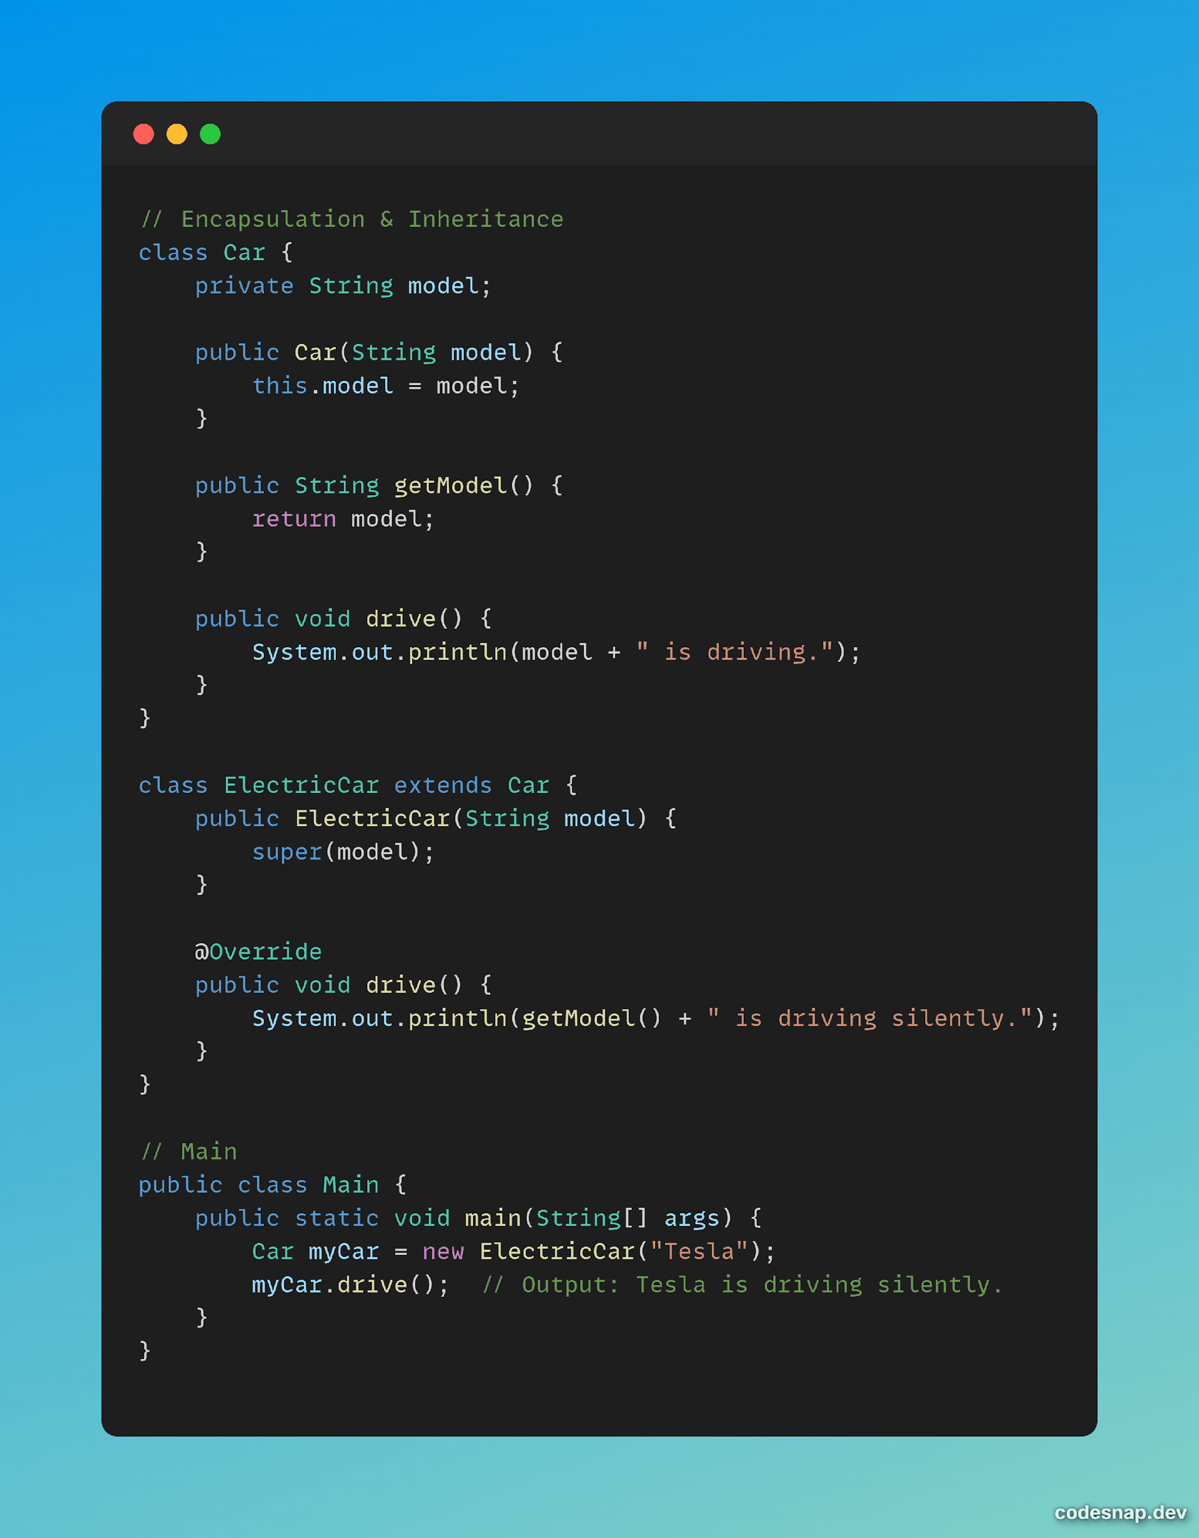

# **6. Conclusion**

The fundamental structure of Java development relies on Object-Oriented Programming principles. Java developers who follow encapsulation and abstraction principles together with inheritance and polymorphism create software systems that remain modular and flexible and easy to maintain.

The importance of OOP in Java remains strong because it appears in academic materials including Fundamentals of OOP and Data Structures in Java as well as contemporary programming guides and community forums. Any Java programmer who wants to build efficient scalable applications must master these fundamental concepts.

# **7. References**

1. <https://www.geeksforgeeks.org/java/object-oriented-programming-oops-concept-in-java/>
2. <https://medium.com/@suraif16/object-oriented-programming-9e4627abf1be>
3. <https://books.google.com.om/books?hl=en&lr=&id=dJ_DXvFnIgoC&oi=fnd&pg=PR13&dq=OOP+in+java&ots=isLVx-YVw3&sig=dM1LkprgMIbGul7x7BtAtcO7FDU&redir_esc=y#v=onepage&q=OOP%20in%20java&f=false>